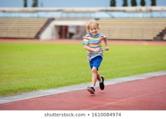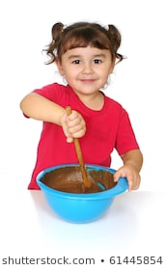Physical Development and the EYFS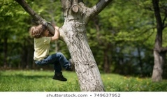
Physical development is one of the three prime areas of learning within the EYFS and it’s really important children get enough physical activity during the day. The area is divided into two sections and it includes:

- Moving and handling - skills enabling children to show good control and coordination in large and small movements. Children are able to handle equipment and tools effectively, including pencils for writing.
- Health and self care - children knowing the importance of good health which includes physical exercise and a healthy diet. Children are able to manage their own basic hygiene and personal needs successfully, including dressing and going to the toilet independently.

The Department of Health say to aim for at least three hours of physical activity across the day for children in early years. Every movement counts and you don't need to do extra activities, just make the most of everyday opportunities. For example when you're changing toddlers' nappies, encourage them to lie down and get up themselves as this helps to strengthen their core muscles and to support and develop their balance and coordination.
Encouraging children to walk up and down stairs by themselves is another good opportunity (it's challenging so they may need your support). Help children learn to use alternate feet by making sure there are safe opportunities in the home or garden for them to climb. Perhaps you could find something for the children to crawl, walk and climb up and over and when they're more confident, provide something bigger or more difficult so that they can get used to moving their feet at different times. It’s great to allow a child to take risks for themselves (obviously supervise but let them discover for themselves). Children, especially boys, love the sense of, and using their strength – allow them to pull big branches along, carry logs or drag a tyre, even mash potatoes using all their might – they will love it and it’s great for building core strength. Get children to play at a table standing rather than sitting – there is no reason why they need to sit for play such as playdough, cooking, water play etc. Encourage children to mark make, thus encouraging fine motor skills – why not draw under the table! Stick a piece of paper underneath a table and get your child to lie down under the table and draw upside down – it makes it fun!
Let babies and children feed themselves finger foods as this helps to promote fine motor skills like grasping and hand-eye coordination (just be aware of choking hazards).
Make physical activity fun and build it into your everyday routines.

Jargon buster – you may hear some of the following words that we often use in pre-school – to clarify their meaning:
- Fine motor skills - when a child uses precise movements using specific body parts, such as the thumb and finger to pick objects up.
- Gross motor skills - when a child uses their whole body in a movement, such as jumping or running.
- Hand-eye coordination - when a child's hands and eyes are working together, for example catching a ball.
- Mark making - this could be anything, from a baby or child making marks with their fingers in sand, to dipping their hands or fingers in paint, to paint a picture.
- Pincer movement - when a child uses an index finger and thumb, to pick up and move objects.
- Tummy time (younger children)- placing a baby on their tummy with engaging toys, lights, mirrors, or you to look at. This can help the baby build gross motor skills as they improve neck, back and arm strength from this position. Short, frequent sessions of tummy time will eventually help support a baby to crawl. During Tummy Time a baby can learn to kick their legs and flap their arms. They can reach and do push ups when they are strong enough. Eventually, they'll learn to roll over to their back from their tummy.

